**CLOUD AND API DEPLOYMENT**

NAME: VIVIAN KERUBO MOSOMI

BATCH CODE: LISUM39

SUBMISSION DATE: 01/12/24

**1.Loading the Data**

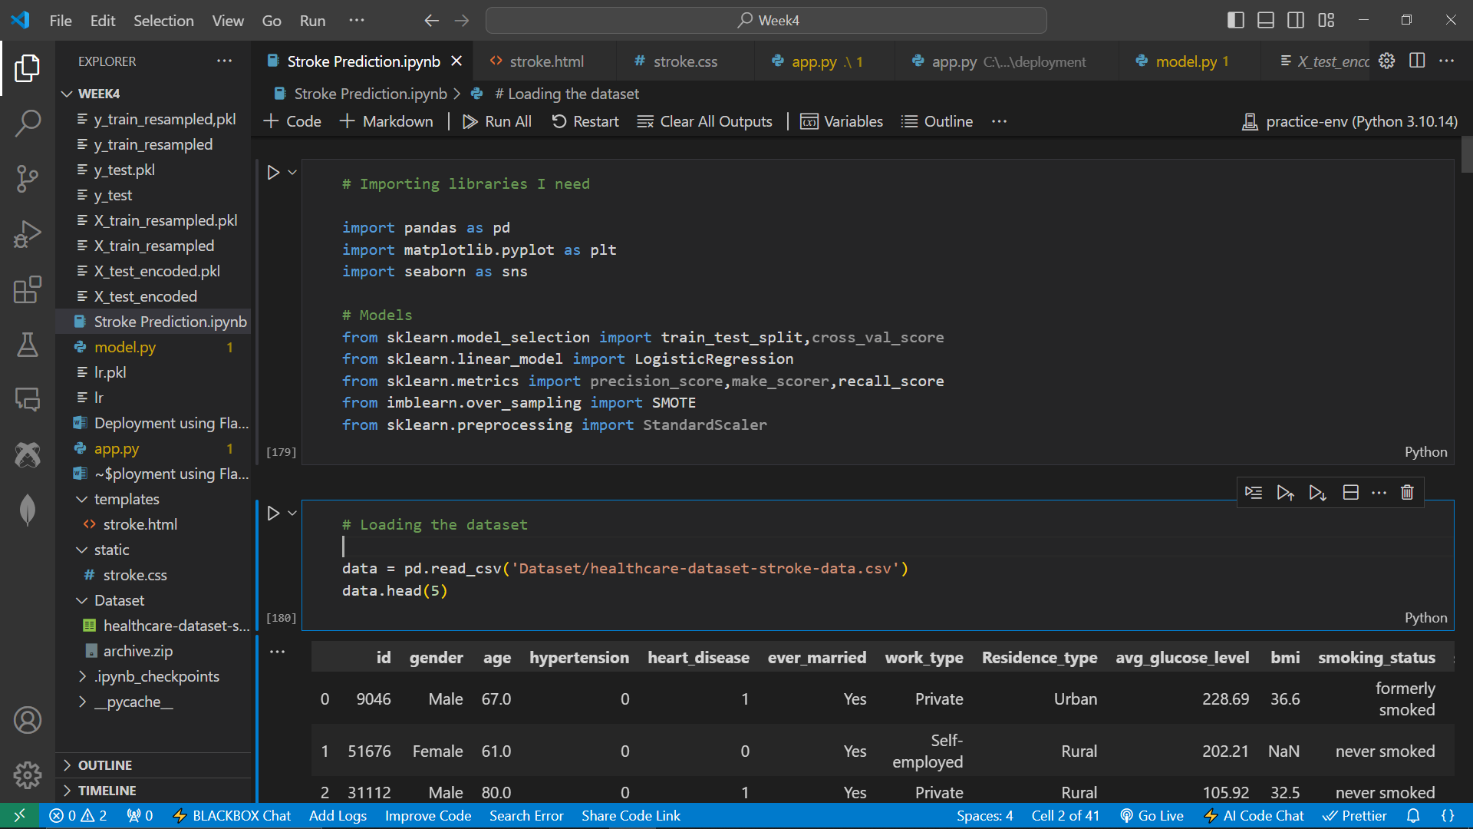

**2.Data Preparation**

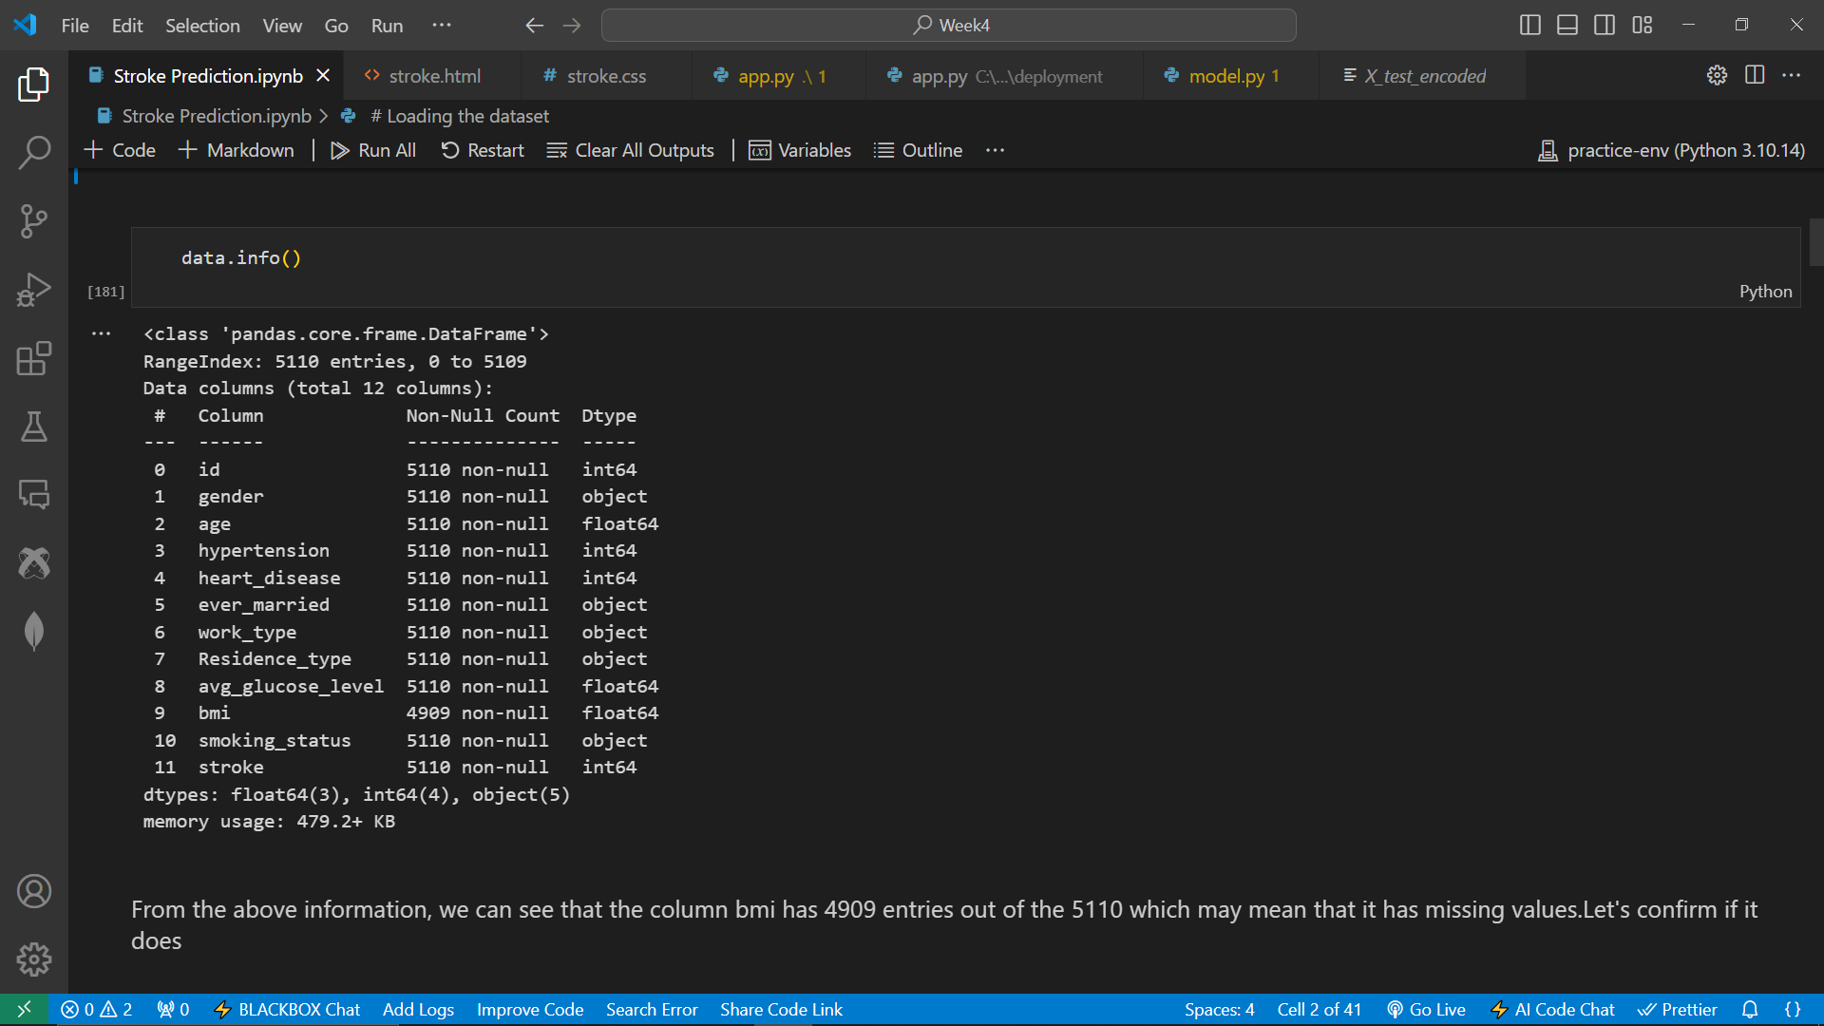

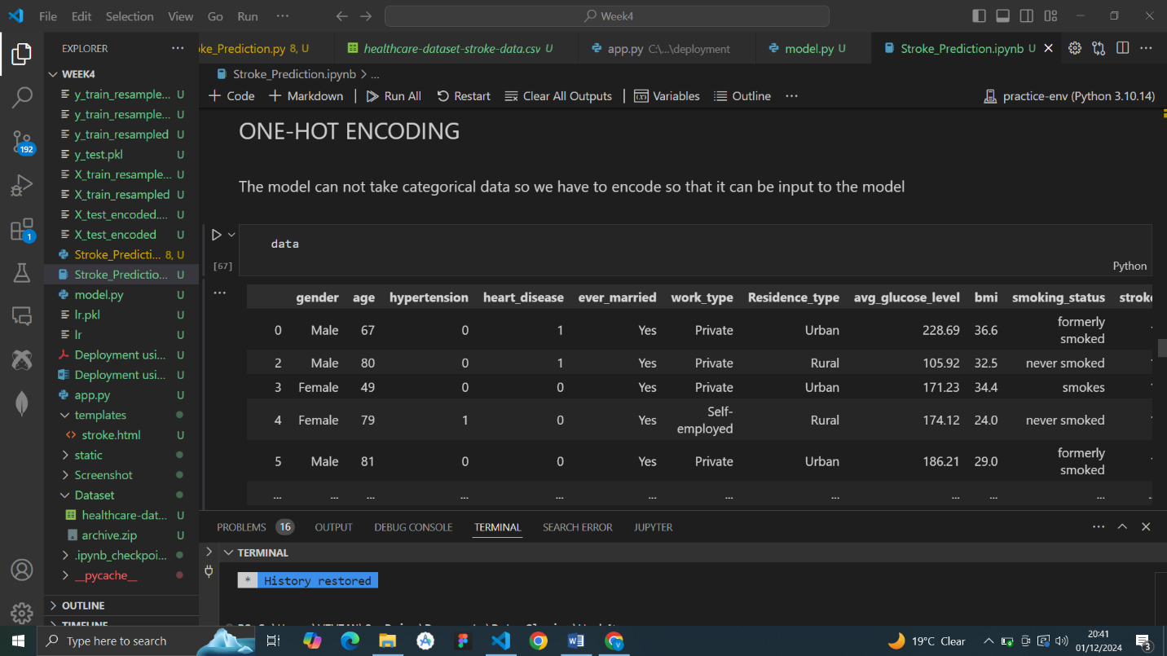 **3. Modelling**

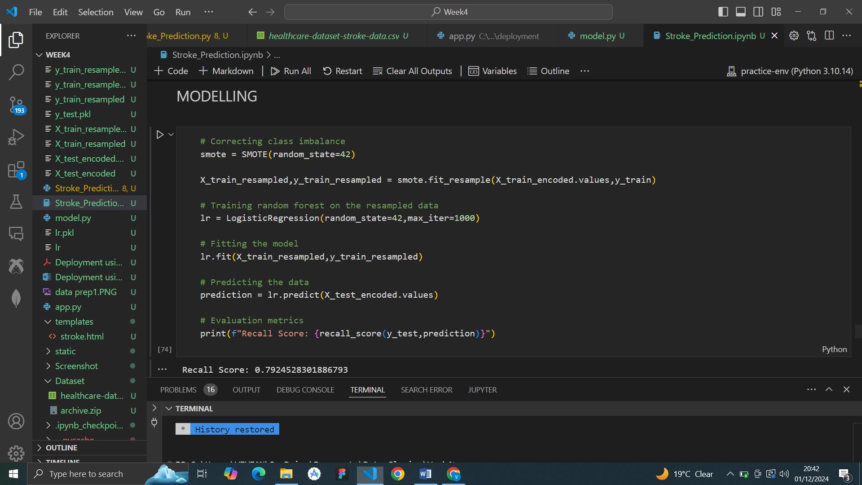

**4.Deployment**

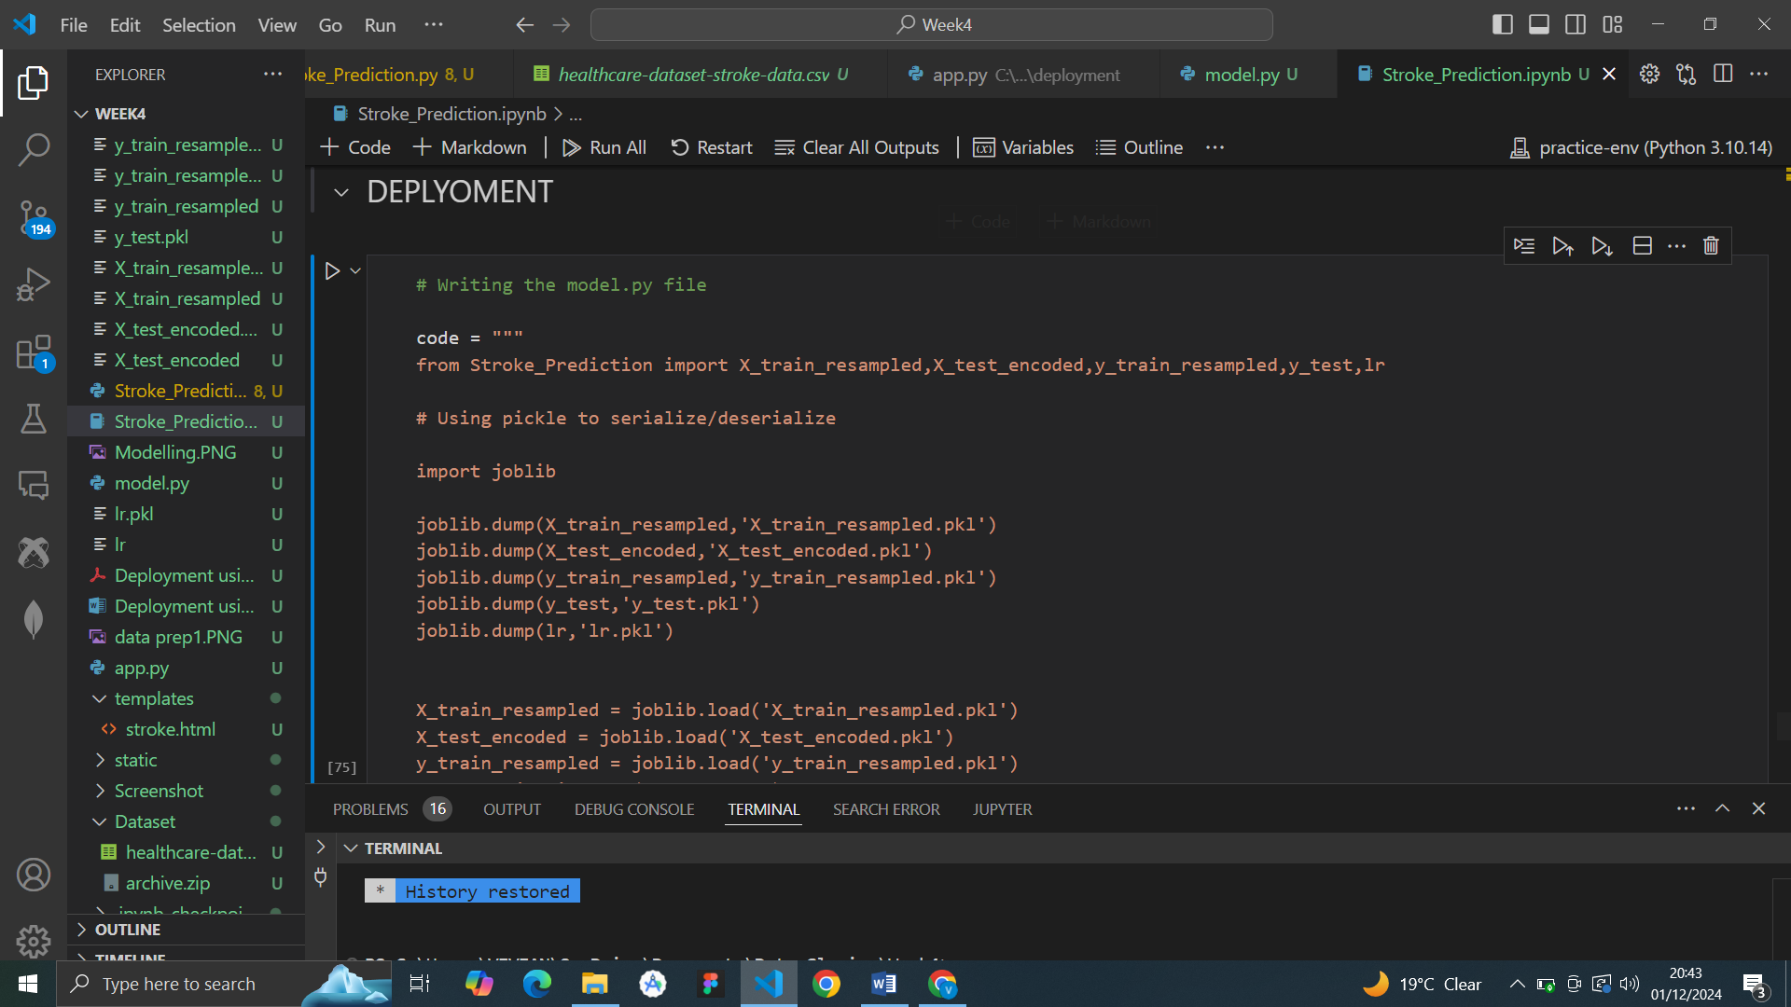

**5.Converting ipynb to .py file**

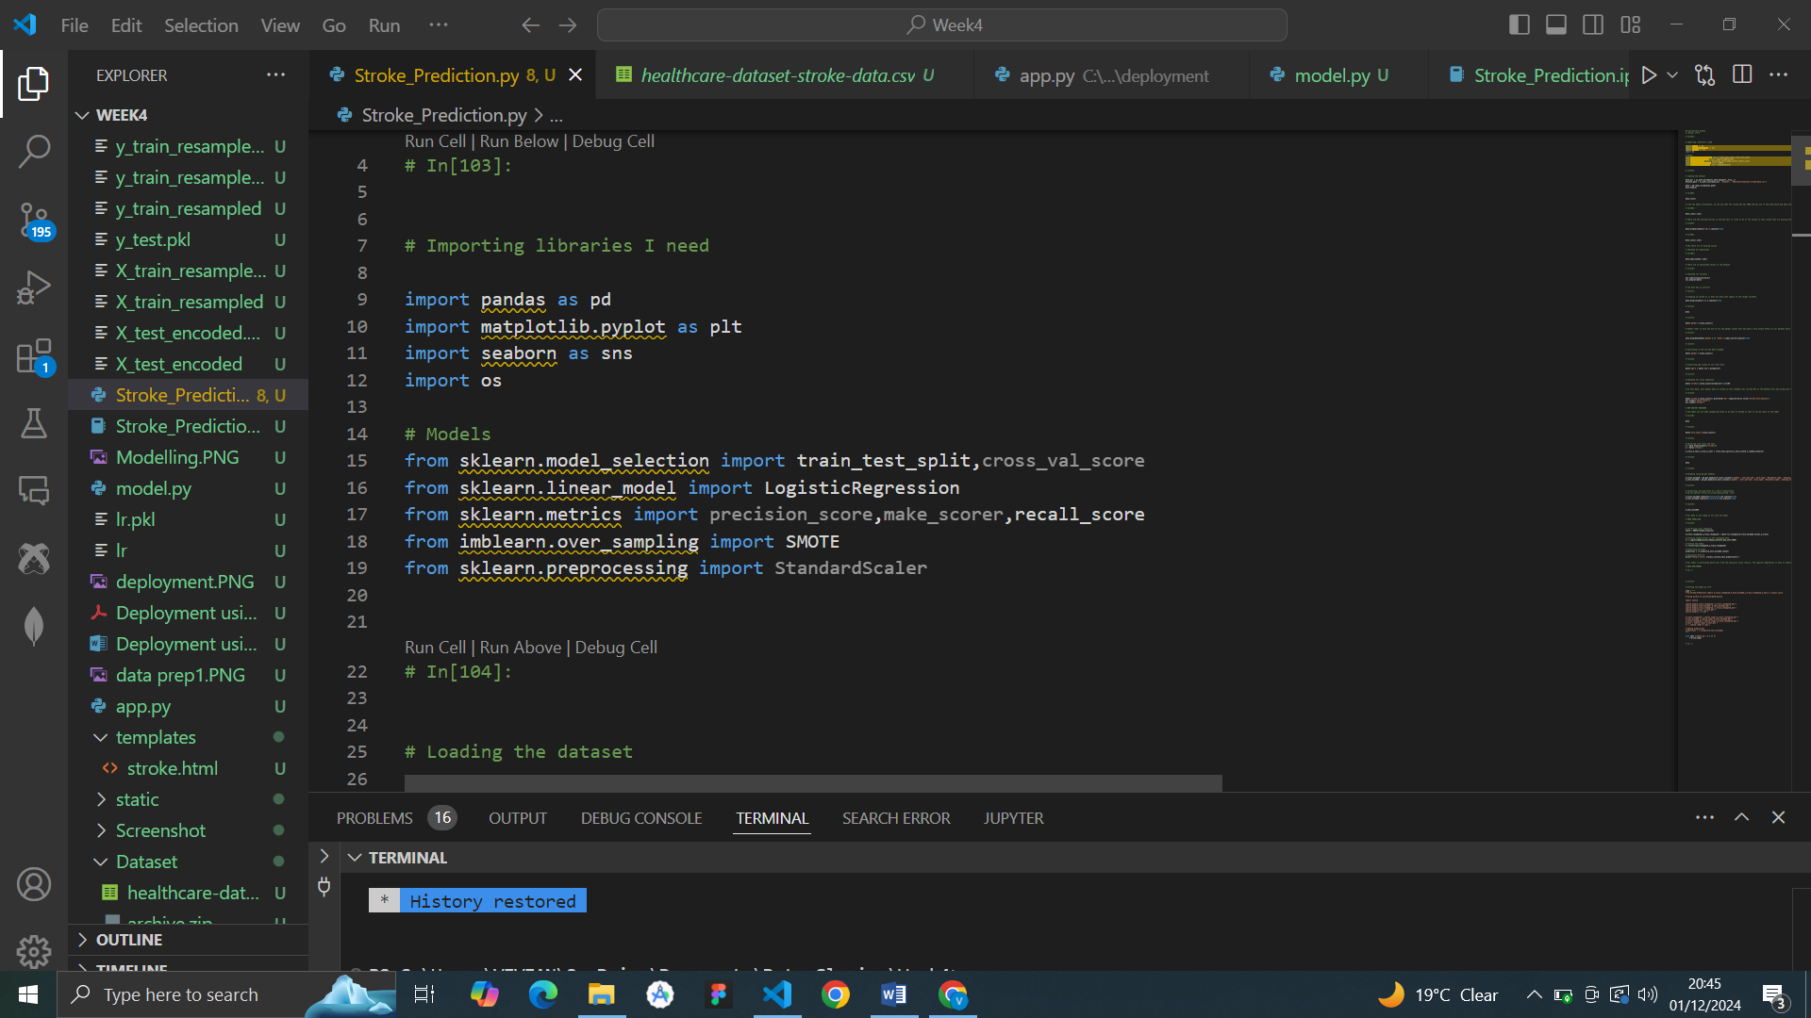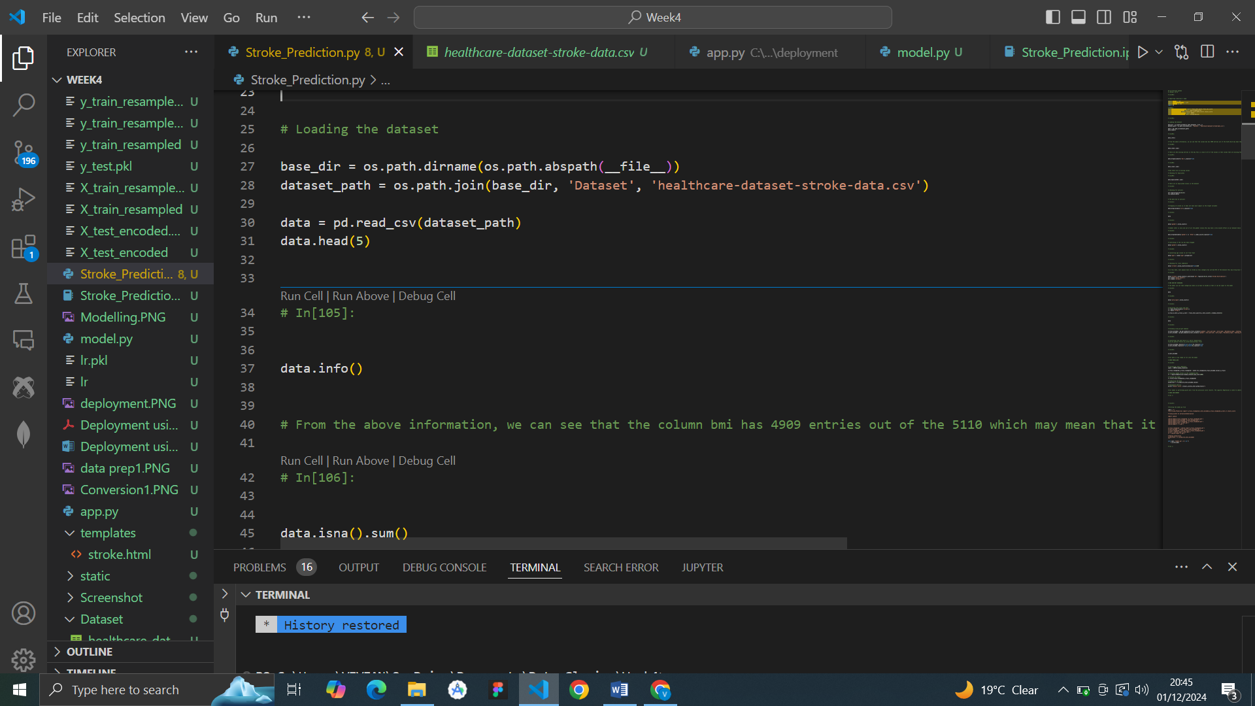

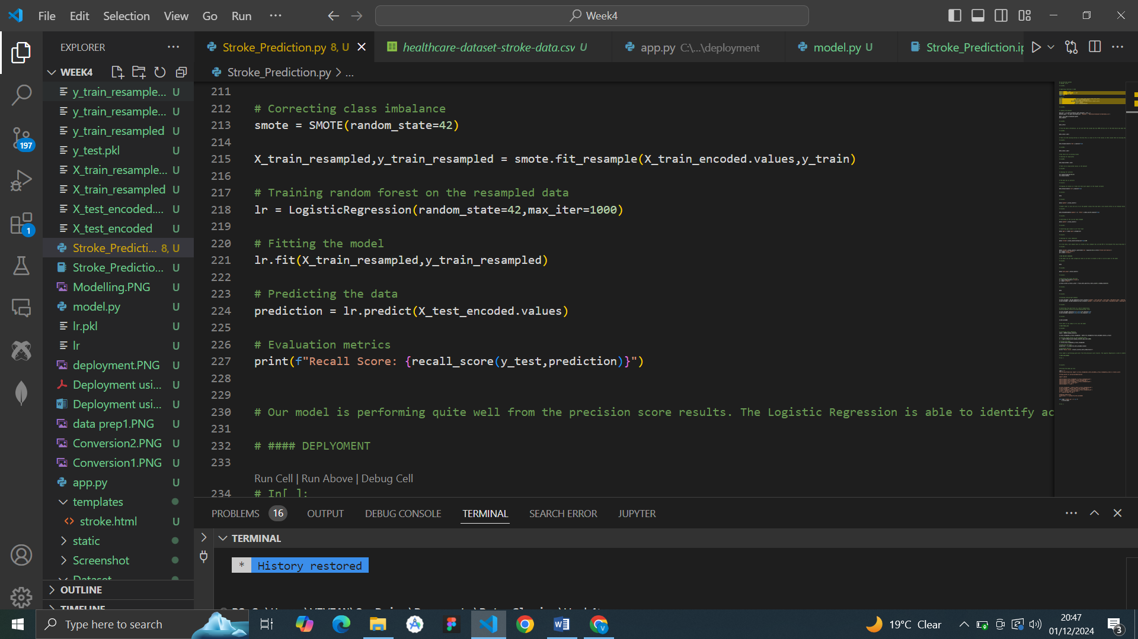

**6. Predicting using serialized files**

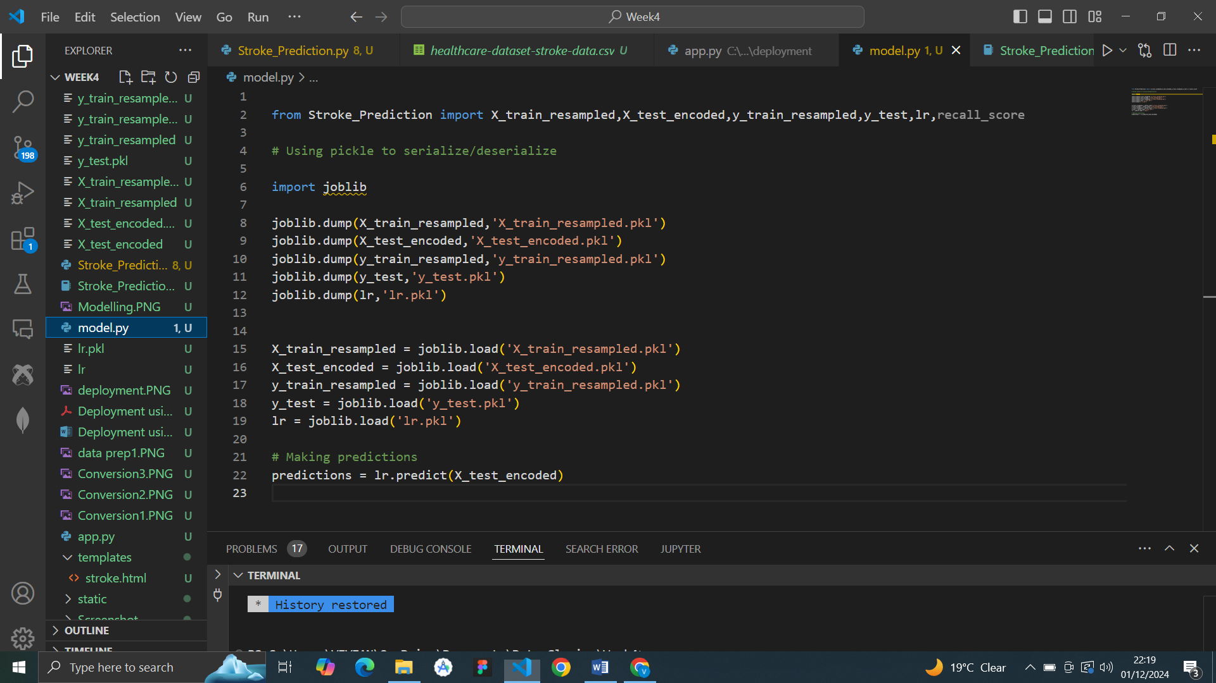

**7. App.py, Html and Css Files**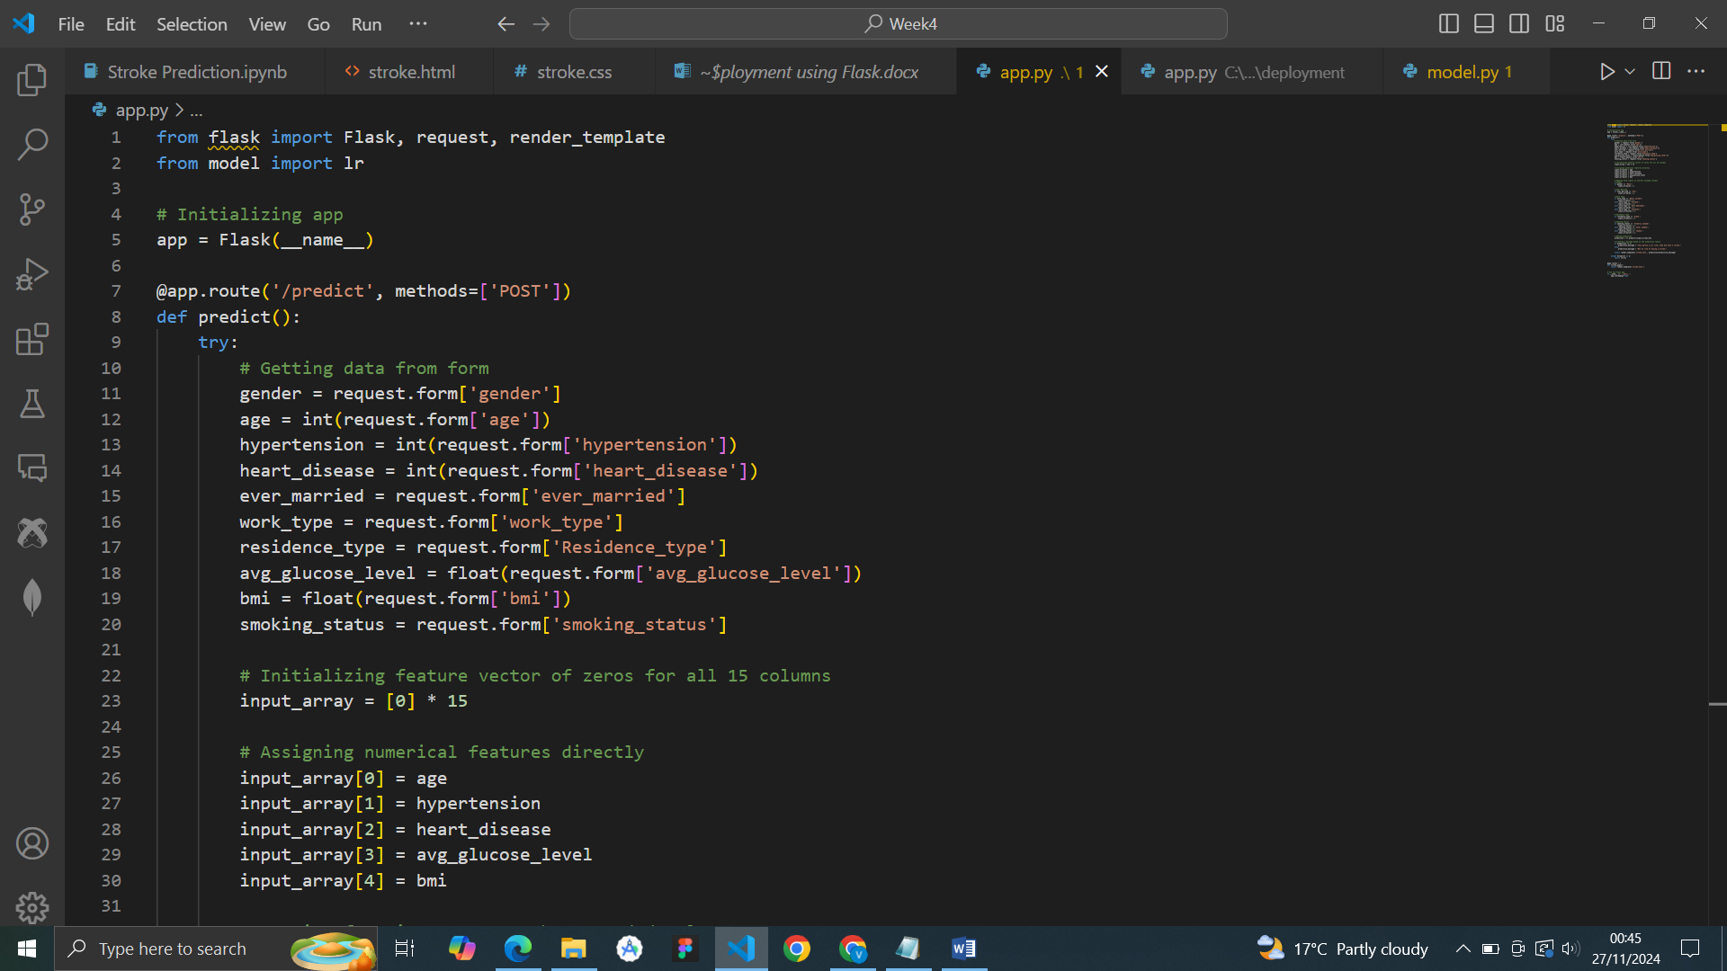

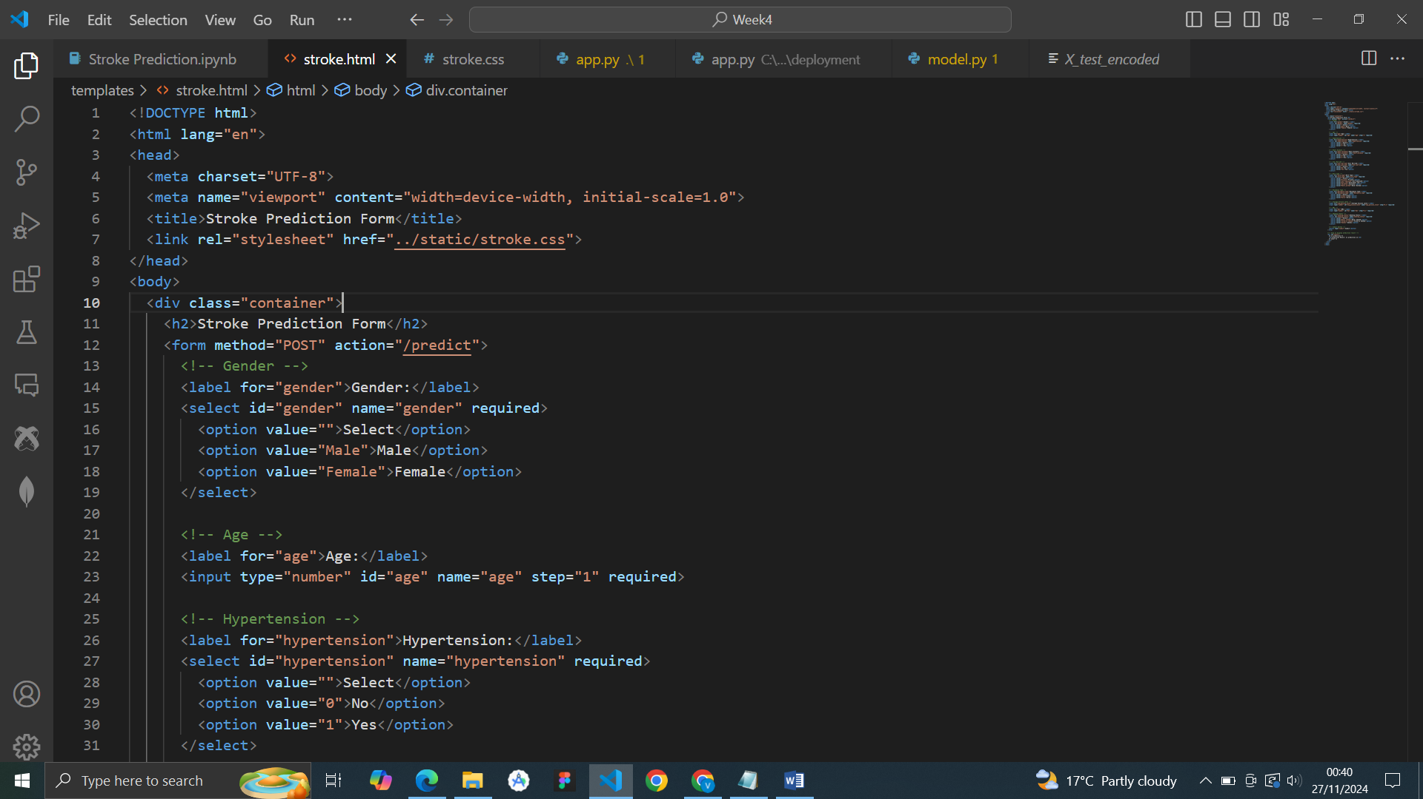

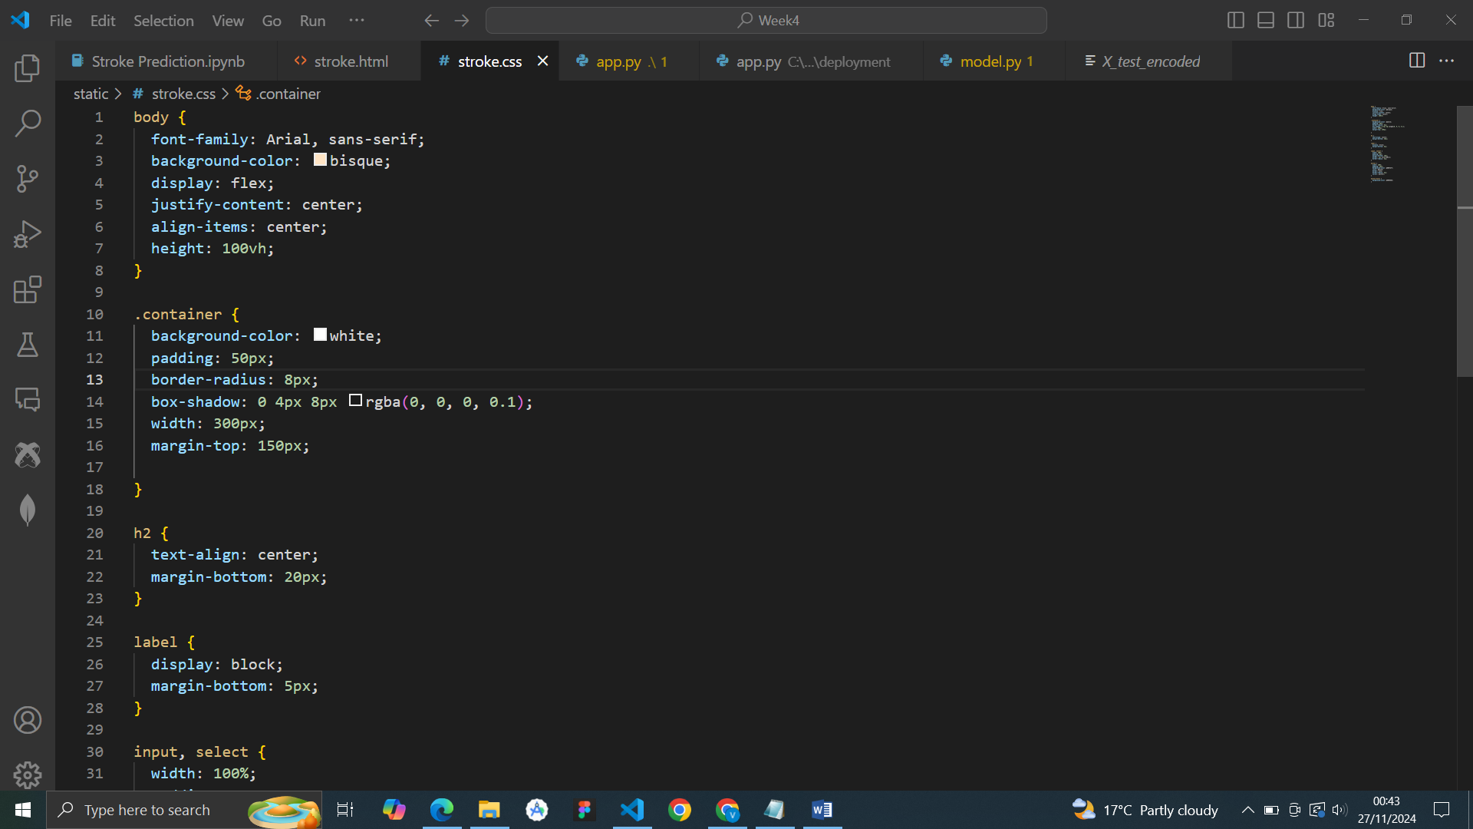

**8.Login To Heroku**

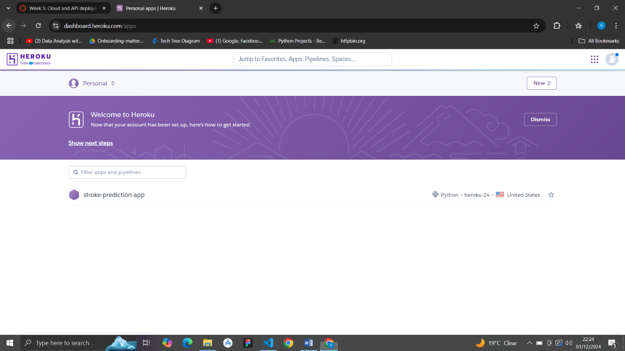

**9.Connect to the app created on Heroku**

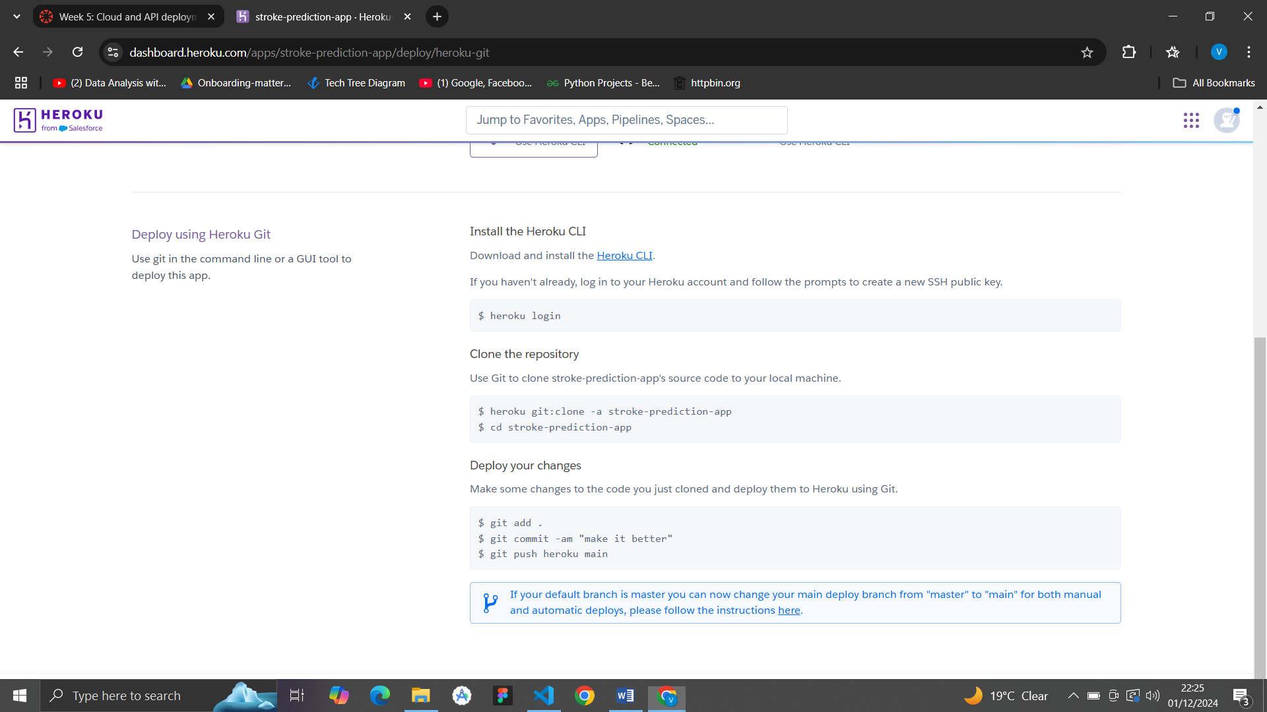

Install the Heroku CLI, and use git bash or command prompt to run the Heroku commands or connect using GitHub

**10.Open the app**

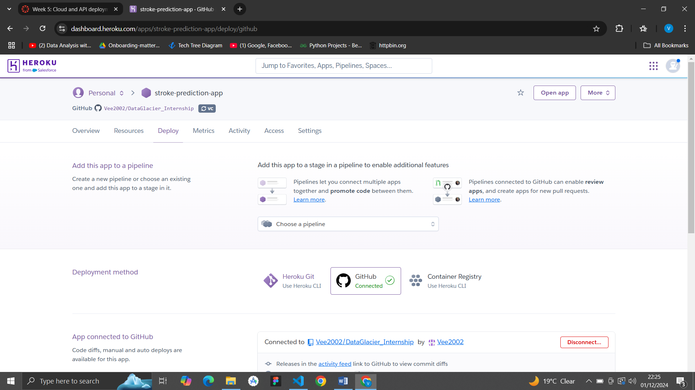

**11.Load the app and fill in the form**

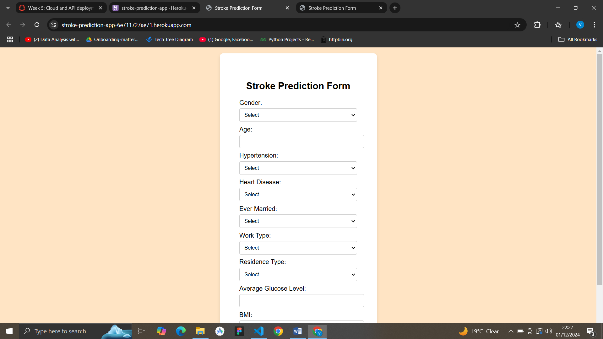

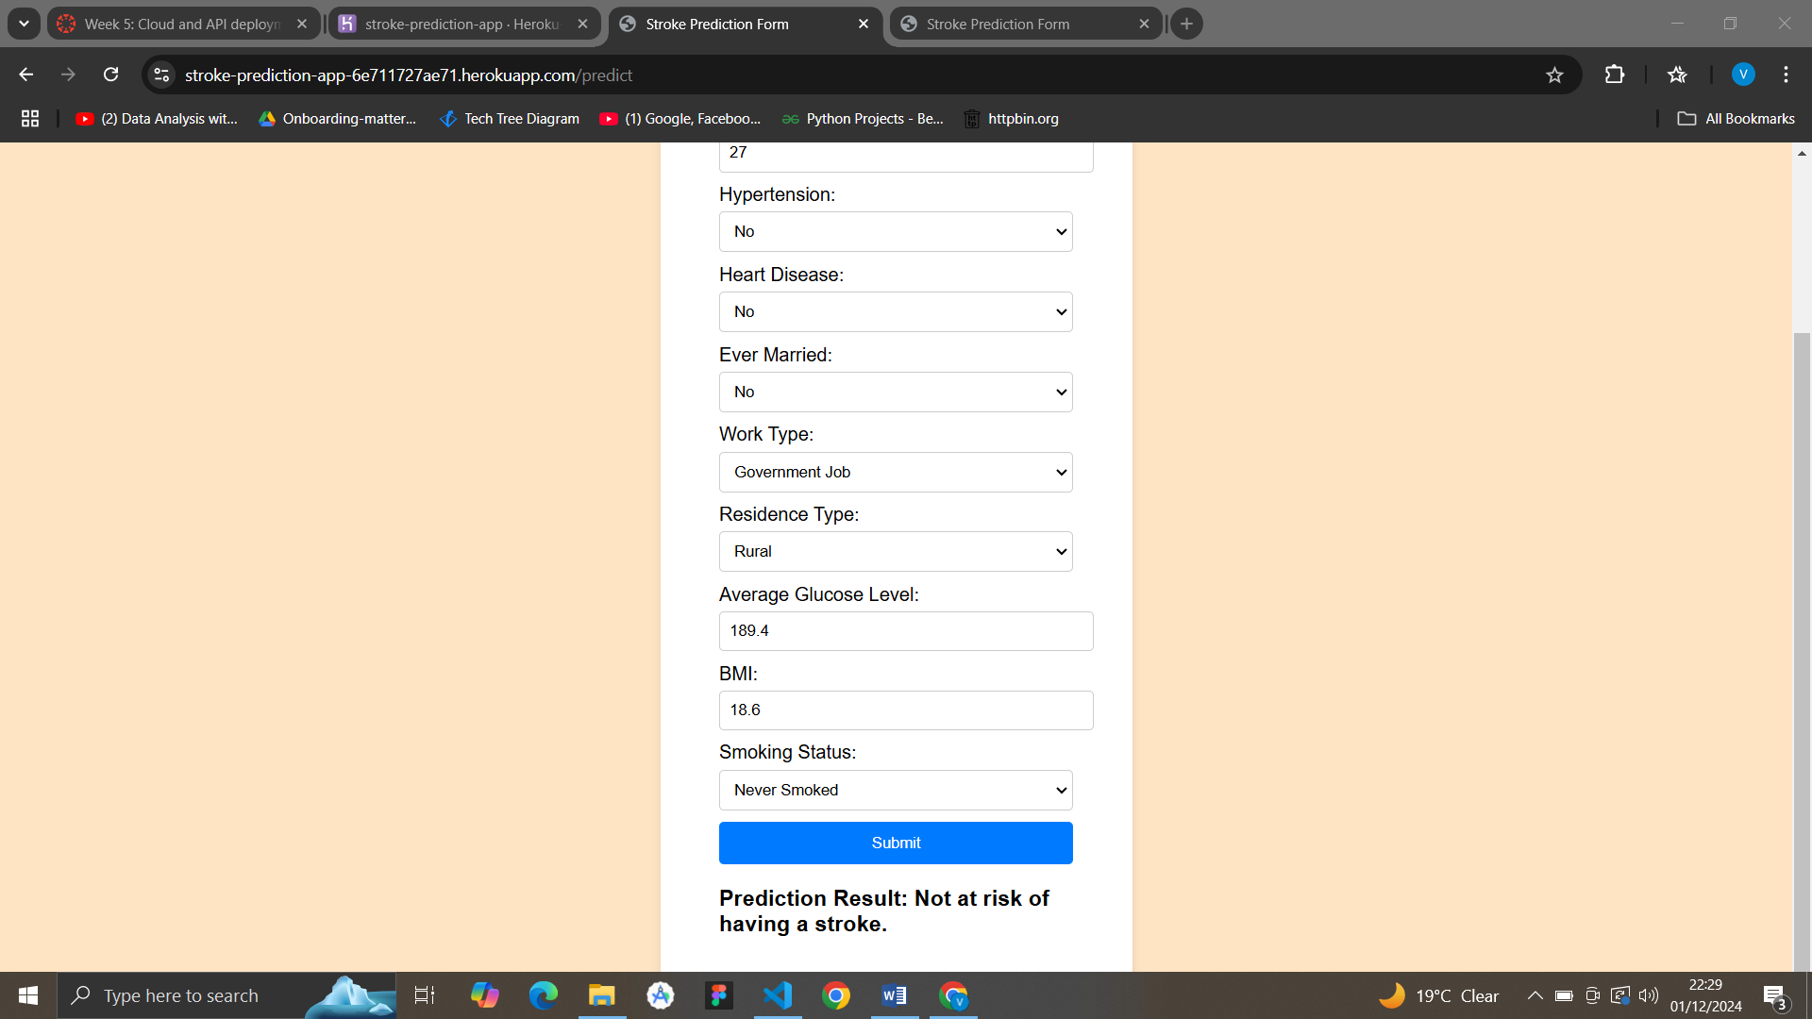

Our application is working well on Heroku.